- CALIFORNIA
- LOCAL

Camp fire evacuation warnings failed to reach more than a third of residents meant to receive calls
By PAIGE ST. JOHN and JOSEPH SERNA
NOV 30, 2018 | 5:20 PM

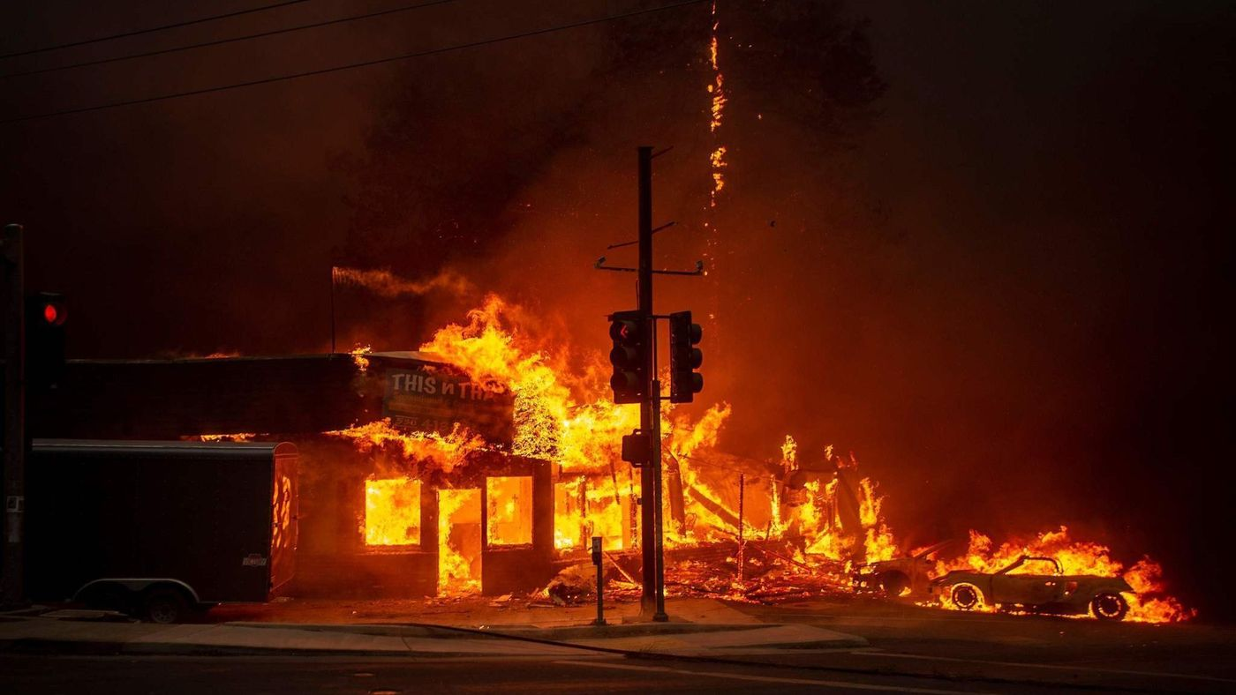
Thousands of people in Paradise never received an evacuation warning call as the Camp fire tore through the town. At least 88 people were killed in the blaze. (Josh Edelson / AFP/Getty Images)
Emergency phone calls telling Paradise residents to run from the massive Camp fire failed to reach more than a third of even the minority who signed up for the warnings, according to a data review by The Times on Friday.
Many of the town’s residents said they relied on calls from alarmed relatives and the sight of approaching flames to flee from California's worst fire on Nov. 8. Logs released Friday show the official warning system reached fewer than 6,200 of the 27,000 who live in the ridge-top community.
At least 88 people died in the blaze and more than 100 are still missing.
The data underscore major flaws in a phone-based warning system that authorities have frequently relied upon in major disasters, including a string of catastrophic fires that have plagued California in the last two years.
Call failure reports released by the Butte County Sheriff’s Office at the request of The Times show that the first evacuation orders requested by firefighters at the scene of the massive blaze frequently failed to connect. About as many calls went to voicemail as were answered by a live person.
Even the calls that were answered went to only a fraction in Paradise — an estimated 30% — who subscribed to the phone-based CodeRed system contracted for by Butte County and owned by California-based OnSolve.
The success rate dropped even further as the fire swept over Paradise and took down cellphone towers and panicked residents picked up their phones and jammed capacity in remaining cell lines. Logs show that more than half of some efforts to reach subscribed Paradise residents simply failed to go through.
“There were like seven to nine towers that went down, so that was huge,” said Paradise Police Chief Eric Reinbold.
The outages also forced the city’s police department to abandon its dispatch center. Reinbold said he believed the fire interrupted efforts to send evacuation orders. He did not know that a full evacuation of the entire town was ever ordered.
“It just rolled through,” he said.
Cellphone companies must report to the state major incidents that cut communications, but those reports to the California Public Utilities Commission are confidential, said a commission spokeswoman.
Leigh Bailey, whose Magalia neighborhood was placed under a mandatory evacuation order hours after the blaze began, said she never received an alert that day even though she had signed up for the CodeRed warning system. She first learned about the fire from a neighbor who didn’t think it would threaten the town, so she went back inside to enjoy coffee cake and tea.
By the time the 54-year-old realized she needed to leave, the main evacuation route was jammed with traffic. She had to navigate a dirt canyon road used by firefighters to escape.
“We never got a single notification. Nothing came over our cellphones,” she said.
Troy Harper, general manager of OnSolve’s public sector division, said a number of factors can delay CodeRed alerts from reaching their targets. Though the company’s system — a network of 12 data centers around the world — can theoretically push out a message to hundreds of thousands of phones in one area in a minute, there is no telecommunications infrastructure in the United States set up to handle an influx that large, Harper said.
In Northern California, he said, the system is generally limited to 2,000 to 4,000 calls a minute. As a result, neighbors can receive the same warning minutes or even hours apart. Such delays were found in Paradise, with more than half an hour delay in the receipt of emergency orders to leave.
The system relies on the same cellphone towers and phone lines strung along power poles that residents are using to call 911, neighbors and relatives during an emergency. All that traffic at once can clog the system, further delaying messages going through, he said.
The morning the Camp fire began, CodeRed alerts hit a busy signal at twice the rate the company typically sees in an emergency, Harper said. He noted that the alert system also sent out texts and emails to those who signed up.
“It’s not a blue sky day, so we expect to see some additional capacity on the infrastructure,” he said. “That’s why we always train our clients to use all modes of applicable communications.”
But the county did not use the federal Wireless Emergency Alert system that employs a separate frequency to send an Amber Alert-style tone, buzz and message to all cellphones in a specific area simultaneously.
"It's one of the tools in the toolbox," Harper said, adding that authorities can also use social media, go door-to-door with loudspeakers and employ the federal emergency alert system that reaches televisions and radios.
Friday’s reports come amid growing concern about the lack of warning residents received before the Camp fire, which destroyed more than 14,000 homes.
At a legislative hearing earlier this week, emergency experts and lawmakers pointed to numerous problems with the town’s evacuation and said the state must work to improve its warning system.
Paradise officials initially limited evacuation orders to just the side of town closest to the fire — hoping to keep the limited exit routes clear for those who needed to escape first.
Some residents heard of the evacuation order from police cars driving by, barking the warnings through a loudspeaker. Others had to find out by door knocks or text messages from neighbors.
The strategy failed — the blaze moved too fast. The police chief said there was no time for a citywide evacuation order — the city’s own system went down in the midst of a partial order.
Some regions of Paradise were not told to evacuate until hours after the blaze had burned through. Resident Keri Bush said her home security cameras showed the house burned by fire roughly two hours before the 4:17 p.m. order to evacuate came through.
California has experienced unprecedented destruction from wildfires over the last two years, which has highlighted major flaws in the emergency alert systems, including a failure to use the latest technology to broadcast Amber Alert-style warnings on cellphones ahead of deadly disasters.
The Sonoma County Sheriff’s Office decided not to send a blanket alert over the federal Wireless Emergency Alert system as the Tubbs fire leaped from wildlands into Santa Rosa last year. Many people were caught unaware about the fire’s path until they were at risk; some were awakened when the flames were on their doorsteps. At least 22 people died.
When the Woolsey fire swept into Malibu last month, many of the city’s residents said they received no warning when the blaze moved into their neighborhoods. Some of them complained to the Los Angeles County Board of Supervisors, demanding that officials come up with a better emergency notification system.
At this week’s legislative hearing, Sen. Hannah-Beth Jackson (D-Santa Barbara) said only 45 of California’s 58 counties have signed on to a wireless emergency alert system that is tied to a federal warning program that transmits communications through cellphones and broadcasters when wildfires start.

Essential California Newsletter
Monday - Saturday

A roundup of the stories shaping California.

Paige St. John

CONTACT

Paige St. John covers criminal justice and investigative stories for the Los Angeles Times from Sacramento. She won the Pulitzer Prize for investigative reporting in 2011. She hails most recently from Florida, where she covered state politics, disasters and property insurance.

Joseph Serna

CONTACT

Joseph Serna is a Metro reporter who has been with the Los Angeles Times since 2012. He previously worked for papers in Orange County and Signal Hill, a 2.2-square-mile city surrounded by Long Beach. He was part of the team that won the Pulitzer Prize for Breaking News for coverage of the 2015 San Bernardino terrorist attack and is a graduate of California’s community college and Cal State systems.
HIDE COMMENTS
Comment Frank W. Bell
While the Emergency Alert System on radio and TV can deliver alerts, and can be made to do so within 3 seconds for earthquakes, it currently is unable to select map polygons. So it is not used much for wildfires. One alert to IPAWS can go to WEA and EAS. The technology can be improved for polygons and other capabilities using digital broadcasting. Advisory committee reports to FEMA and the FCC have been made. However no decision to act has been made. Comparing Western Samoa and American Samoa in the 2009 tsunami shows that using EAS reduced fatalities by about 4.7 to 1.

